UML is a language (Unified Modeling  
Language) for models  
▪ technical and graphical specification  
▪ Graphic notation to visualize models  
▪ Not a method or procedure

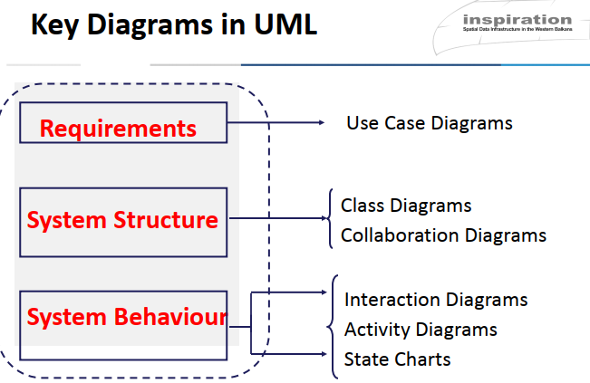

1. Use Case Diagram:

**This diagram shows the interactions between actors (users) and the system (your website).** It's a great starting point for understanding the overall functionality of the website and identifying the main user stories.

[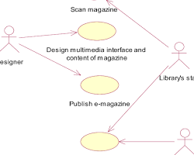Opens in a new window[](https://www.researchgate.net/figure/A-use-case-diagram-for-e-magazines_fig3_251364130)www.researchgate.net](https://www.researchgate.net/figure/A-use-case-diagram-for-e-magazines_fig3_251364130)

Use Case Diagram for Magazine Website

2. Class Diagram:

**This diagram shows the classes that make up the system, their attributes, and their relationships.** It's helpful for understanding the data model of the website and how different parts of the system interact with each other.

[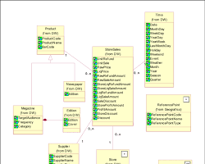Opens in a new window[](https://www.researchgate.net/figure/UML-Class-Diagram-for-the-Magazine-Retailer_fig3_228723847)www.researchgate.net](https://www.researchgate.net/figure/UML-Class-Diagram-for-the-Magazine-Retailer_fig3_228723847)

Class Diagram for Magazine Website

3. Sequence Diagram:

**This diagram shows the sequence of messages that are exchanged between objects in a specific scenario**. It's helpful for understanding the flow of data and control in a specific use case.

[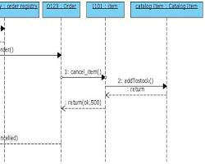Opens in a new window[](http://www.programsformca.com/2012/03/sequence-diagram-online-shopping-cancel.html)www.programsformca.com](http://www.programsformca.com/2012/03/sequence-diagram-online-shopping-cancel.html)

Sequence Diagram for Magazine Website

4. State Diagram:

**This diagram shows the different states that an object can be in and the events that can cause it to transition between states.** It's helpful for understanding the behavior of individual objects in the system.

[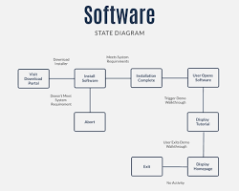Opens in a new window[](https://www.visme.co/templates/infographics/online-shopping-state-diagram-templates-1425285613/)www.visme.co](https://www.visme.co/templates/infographics/online-shopping-state-diagram-templates-1425285613/)

State Diagram for Magazine Website

5. **Activity Diagram**:

**This diagram shows the flow of activities in a complex process.** It's helpful for understanding the steps involved in a specific task, such as publishing an article or managing subscriptions.

[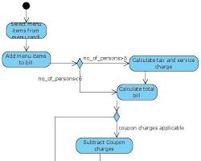Opens in a new window[](http://www.programsformca.com/2012/03/activity-diagram-for-restaurant-exam.html)www.programsformca.com](http://www.programsformca.com/2012/03/activity-diagram-for-restaurant-exam.html)

Activity Diagram for Magazine Website

In addition to these diagrams, you may also need to create other UML diagrams depending on the specific features and functionality of your website. For example, you might need a deployment diagram to show how the website is deployed on different servers, or a component diagram to show the different components that make up the website.

Here are some tips for choosing the right UML diagrams for your magazine website:

* Start with the use case diagram to identify the main user stories.
* Use the class diagram to understand the data model of the website.
* Create sequence diagrams for the most important use cases.
* Use state diagrams to understand the behavior of individual objects.
* Use activity diagrams to document complex processes.

Here's a common order of implementation for UML diagrams in a news website project:

1. Use Case Diagram:
   * Start by defining the primary actors (visitors, editors, administrators) and their interactions with the system.
   * This helps establish a clear understanding of the website's overall functionality and user stories.
2. Class Diagram:
   * Model the core classes, their attributes, and relationships to capture the website's data structure.
   * This includes entities like articles, categories, users, comments, and media assets.
3. Activity Diagram:
   * Map out the flow of key processes, such as article submission, review, publication, and user registration.
   * This helps visualize the steps involved in these essential tasks.
4. Sequence Diagram:
   * Detail the interactions between objects for specific use cases.
   * For example, illustrate how objects communicate during article retrieval, commenting, or user login.
5. State Diagram:
   * Model the behavior of dynamic objects, especially those with multiple states (e.g., articles transitioning from draft to published).
   * This helps ensure clarity in object behavior and potential transitions.

Key Considerations:

* Iterative Approach:
  + Diagrams are often created and refined throughout the development process.
* Agile Methodology:
  + Focus on diagrams directly supporting current development iterations.
* Team Collaboration:
  + Involve stakeholders, developers, and designers in diagram creation and review.
* Tool Support:
  + Utilize UML modeling tools to create, maintain, and share diagrams effectively.

Remember:

* Adapt the order and specific diagrams to match your project's unique requirements and development approach.
* Prioritize diagrams that provide the most value for understanding and communicating the system's design and functionality.

**Understanding the Logical Model:**

* Blueprint for Data Structure: The logical model forms a conceptual representation of the data entities, their attributes, and relationships without being tied to a specific database technology.
* Focus on Business Requirements: It prioritizes understanding business needs and capturing real-world concepts accurately, ensuring the database aligns with organizational goals.
* Foundation for Physical Model: It serves as a clear and concise blueprint for translating into the physical implementation, ensuring a well-structured database.

Key Steps in Translation to Physical Model:

1. Mapping Entities to Tables: Entities in the logical model become tables in the physical model.
2. Attributes to Columns: Attributes of entities become columns within their corresponding tables.
3. Implementing Relationships: Relationships between entities are implemented using foreign keys, ensuring data integrity and consistency.
4. Data Types and Constraints: Specific data types and constraints are assigned to columns, enforcing data validity and quality.
5. Indexing: Indexes are created for efficient retrieval of data based on specific criteria.
6. Normalization: The database is normalized to minimize redundancy and improve data integrity.
7. Performance Optimization: Physical design considers performance factors like query patterns, data volumes, and hardware resources.

Benefits of This Approach:

* Clear Understanding: Focusing on the logical model first ensures a thorough understanding of the data structure and business requirements.
* Technology Independence: The logical model is not bound to a specific database system, allowing flexibility in choosing the most suitable platform.
* Sound Foundation: It provides a solid basis for creating a well-structured and optimized physical model.
* Maintainability: Changes in business requirements can be easily reflected in the logical model and subsequently translated to the physical model.

In summary, designing the logical model first and then carefully translating it into the physical model helps:

* Ensure the database accurately represents business needs.
* Create a well-organized and efficient physical database structure.
* Facilitate adaptability to future changes.
* Enhance overall database maintainability and performance.

**1. Logical Data Model:**

* share the logical data model, which includes:
  + Entities (tables)
  + Attributes (columns)
  + Relationships between entities (foreign keys)

2. Database Technology:

* Specify the chosen database technology (e.g., MySQL, PostgreSQL, Oracle, SQL Server, etc.).

3. Performance Considerations:

* Highlight any performance requirements or constraints that might influence the physical model's design.

4. Additional Requirements:

* Mention any unique indexing, normalization, or data integrity needs.

5. Specific Use Case Details:

* Describe the functionality and data interactions involved in the use case.

Once I have this information, I can assist you in crafting the appropriate physical model, incorporating the following aspects:

- Table Structure:

* Mapping logical entities to physical tables.
* Defining table names and column names.
* Assigning appropriate data types and constraints to columns.

- Relationships:

* Implementing relationships using foreign keys.
* Ensuring referential integrity.

- Indexes:

* Creating indexes for efficient data retrieval.

- Normalization:

* Optimizing tables through normalization to minimize redundancy and data anomalies.

- Performance Tuning:

* Considering performance factors like query patterns, data volumes, and hardware resources.

1. Relationships:

* How are users categorized into admins, editors, and readers? Do users have roles or specific types?
* How are articles related to users? Can any user submit articles, or just editors?
* How are article ratings linked to articles and users? Can any user rate any article?

2. Attributes:

* What are the key attributes for each entity? For example, for articles: title, content, author, publication date, category, etc.
* What additional attributes are relevant for users (roles, subscriptions, etc.) and other entities?

3. Constraints:

* Are there any unique constraints on any attributes (e.g., unique ID for users, unique title for articles)?
* Are there any foreign key constraints between entities?

4. Additional Requirements:

* Are there any specific performance considerations? Do you need fast search or filtering on certain attributes?
* Are there any security requirements to manage access control for different user roles?

Once I have this information, I can provide you with a more detailed physical model, including:

* Table structure: Names, attributes, data types, and constraints for each table.
* Relationships: Foreign key definitions to specify connections between tables.
* Normalization: Optimization of table structures to avoid redundancy and maintain data integrity.
* Indexing: Suggested indexes for optimizing data retrieval based on usage patterns.

Use Case Diagram

Actors:

* Reader: Represents a user who visits the website to read articles.
* Editor: Represents a user responsible for creating, editing, and managing articles.
* Admin: Represents a user with administrative privileges, such as managing users, settings, and overall website operations.

Use Cases:

* View Articles:
  + Reader browses and reads published articles.
  + Reader searches for articles using keywords or filters.
* Manage Account:
  + Reader creates an account, logs in, and updates their profile information.
* Read Article:
  + Reader views the full content of an individual article.
* Submit Article:
  + Editor creates a new article, including title, content, categories, and tags.
* Edit Article:
  + Editor modifies existing articles, including content, metadata, and publication status.
* Publish Article:
  + Editor makes an article publicly visible on the website.
* Manage Articles:
  + Editor views a list of articles, filters them, and changes their status (published, draft, archived).
* Moderate Comments:
  + Editor approves, rejects, or deletes comments submitted by readers.
* Manage Users:
  + Admin creates, edits, and deletes user accounts.
  + Admin assigns roles (reader, editor, admin) to users.
* Manage Settings:
  + Admin configures website settings, such as appearance, functionality, and security.
* View Reports:
  + Admin generates reports on website usage, article popularity, and user activity.

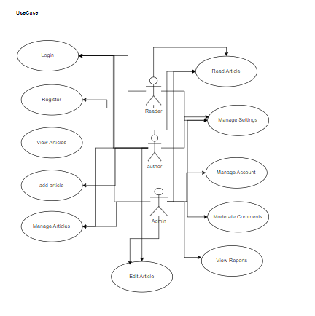

Class Diagram

There are several types of connections between use cases in a use case diagram, each describing a different kind of relationship between those functionalities. Here's a breakdown of the most common ones:

1. Association:

* Indicates a general interaction or relationship between two use cases.
* For example, the use case "Read Article" might be associated with the use case "Rate Article," meaning a reader can rate an article while reading it.

2. Include:

* This relationship represents one use case incorporating the functionality of another.
* For example, the use case "Publish Article" might include the use case "Edit Article," meaning editing happens before publishing.

3. Extend:

* This connection depicts optional or conditional behavior that adds to the base use case under specific circumstances.
* For example, the use case "View Articles" might be extended by "Search Articles," meaning searching is an optional add-on to browsing available articles.

4. Generalization:

* This relationship indicates inheritance between use cases, similar to class inheritance in object-oriented programming.
* For example, the use case "Manage Articles" might be generalized to "Manage Content," implying broader functionality covering other content types as well.

5. Communication:

* This association specifically signifies direct communication or data exchange between two use cases.
* For example, the use case "Submit Article" might communicate with the use case "Review Article" by sending the submitted article for editor review.

Additional Notes:

* You can combine these connections to represent more complex relationships. For example, a use case could both include and extend another.
* The choice of connections depends on the specific functionality and relationships within your system.
* Use clear labels and descriptions to clarify the meaning of each connection in your use case diagram.

By understanding these different types of connections, you can effectively model the intricate interactions and dependencies between use cases in your system, creating a more detailed and accurate representation of its overall functionality.

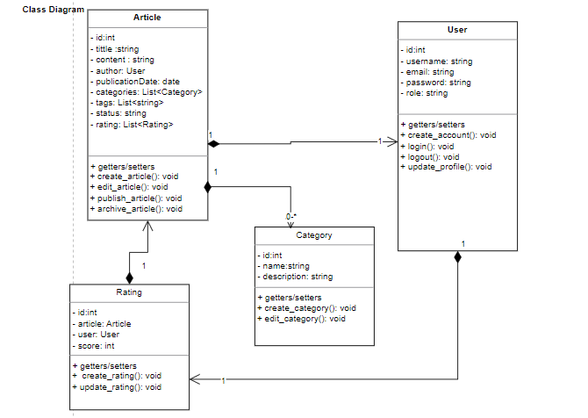

**Classes**:

1. Article:
   * Attributes:
     + id (unique identifier)
     + title
     + content
     + author (link to User class)
     + publication_date
     + categories (list of Category objects)
     + tags (list of strings)
     + status (e.g., draft, published, archived)
     + rating (average rating from users)
   * Operations:
     + create_article()
     + edit_article()
     + publish_article()
     + archive_article()
2. User:
   * Attributes:
     + id (unique identifier)
     + username
     + email
     + password (hashed)
     + role (reader, editor, admin)
     + profile_info (optional)
   * Operations:
     + create_account()
     + login()
     + logout()
     + update_profile()
3. Category:
   * Attributes:
     + id (unique identifier)
     + name
     + description
   * Operations:
     + create_category()
     + edit_category()
4. Rating:
   * Attributes:
     + id (unique identifier)
     + article (link to Article class)
     + user (link to User class)
     + score (numerical rating)
   * Operations:
     + create_rating()
     + update_rating()
5. Comment:
   * Attributes:
     + id (unique identifier)
     + article (link to Article class)
     + user (link to User class)
     + content
     + status (approved, pending, rejected)
   * Operations:
     + create_comment()
     + approve_comment()
     + reject_comment()

Relationships:

* Association:
  + User <-> Article (many-to-many, users can write and read articles)
  + Article <-> Category (many-to-many, articles can belong to multiple categories)
  + Article <-> Rating (one-to-many, an article can have multiple ratings)
  + Article <-> Comment (one-to-many, an article can have multiple comments)
* Inheritance:
  + You might consider inheritance for different user roles (e.g., Editor inherits from User).

Sequence Diagram

1. Reader Viewing an Article:

Actors: Reader, Web Server, Article Database

Sequence of Interactions:

1. Reader clicks on an article link.
2. Web Server receives the request.
3. Web Server retrieves article data from the Article Database.
4. Article Database sends the article data to the Web Server.
5. Web Server renders the article content on the web page.
6. Web Server sends the web page to the Reader's browser.
7. Reader views the article on their screen.

Visual Representation Guidelines:

* Draw vertical lifelines for each actor and object.
* Place messages (horizontal arrows) between lifelines to show interactions.
* Sequence messages from top to bottom, chronologically.
* Use activation bars (thin rectangles) on lifelines to indicate when objects are active.
* Add notes or comments as needed for clarity.

2. Editor Submitting an Article:

Actors: Editor, Web Server, Article Database

Sequence of Interactions:

1. Editor fills out the article submission form.
2. Editor clicks the "Submit" button.
3. Web Server receives the form data.
4. Web Server validates the data.
5. Web Server creates a new article record in the Article Database.
6. Article Database stores the article data.
7. Web Server sends a confirmation message to the Editor.
8. Editor receives the confirmation.

Visual Representation Guidelines:

* Follow the same guidelines as for "Reader Viewing an Article."
* Add conditional blocks (e.g., "alt" frames) for error handling or alternative flows.

Key Considerations:

* Adapt the diagrams to reflect specific features and interactions of your website.
* Consider additional actors or objects as needed.
* Use clear and concise labels for better understanding.
* Ensure the diagrams accurately represent the system's behavior and message flow.